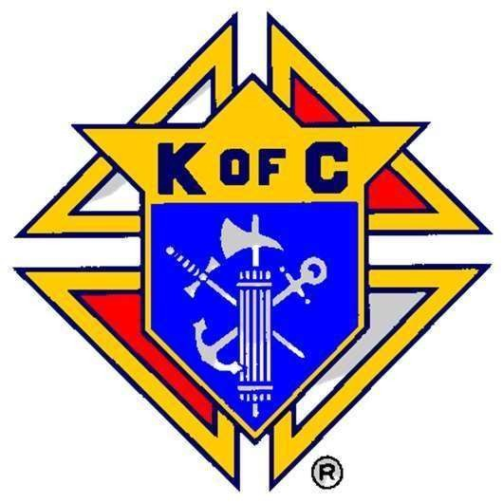

2025-2026 Peoria Diocese Chapter Officer List

|  |  |  |  |
| --- | --- | --- | --- |
| Office | Council | Email | Number |
| President Stephen Scherer | 634 | coachzamhs@sbcglobal.net | 815-830-2692 |
| Vice-President John Dudek | 3934 | jsdudek1951@sbcglobal.net | 309-242-6925 |
| Secretary Ed Cler | 13103 | edwcler@gmail.com | 217-493-7564 |
| Treasurer Andy Ehrlich | 891 | andyaehrlich@hotmail.com | 217-549-9349 |
| Warden Nicholas Walters | 14870 | sirnwalters@gmail.com | 309-868-5441 |
| Inside Guard Mark Tressell | 556 | mtressell@yahoo.com | 309-509-3790 |
| Outside Guard David Volz | 3507 | advolz@outlook.com | 309-347-8505 |
| 3 Year Trustee Louis Kanowsky | 427 | skykan@comcast.net | 309-210-2622 |
| 2 Year Trustee Mike Appell | 12407 | michael.appell@gmail.com | 309-360-3396 |
| 1 Year Trustee Sam Joseph | 427 | samjosephspecialties@yahoo.com | 309-693-8498 |